NOTICE OF FINDING OF NO SIGNFICANT IMPACT AND
NOTICE OF INTENT TO REQUEST RELEASE OF FUNDS

Date of Publication: June 3, 2026
City of Philadelphia
Department of Planning and Development
1515 Arch Street, 13th Floor
Philadelphia, PA 19102

These notices shall satisfy two separate but related procedural requirements for activities to be undertaken by the City of Philadelphia.

REQUEST FOR RELEASE OF FUNDS
On or after June 24th, the City of Philadelphia will submit a request to the U.S. Department of Housing and Urban Development (HUD) for the release of Community Development Block Grant Disaster Recovery (CDBG-DR) program funds under the Disaster Relief Supplemental Appropriations Act, 2022 (Public Law 117-43) and the Continuing Appropriations Act, 2023 (Public Law 117–180), as amended, to undertake the following project:

Project/Program Title: S 42nd Street Combined Waste and Stormwater Pumping Station

Purpose: The Philadelphia Water Department (PWD) proposes to construct an above-ground, flood‑resilient pump station on the existing PWD‑owned parcel. The site’s current pump station is completely below ground and was originally designed to receive dry weather wastewater flows from the eastern half of West Philadelphia and feed into PWD’s Southwest Philadelphia Water Pollution Control Plant. During Hurricane Ida, the station became inundated with stormwater, which submerged the station’s pumps, motors, and all electrical equipment, causing the station to cease operating. This project will increase the pumping capacity to 100 million gallons per day (MGD), allowing the station to convey additional wet weather flows to the Southwest Water Pollution Control Plant for treatment, and will prevent both untreated water from flowing into the river as well as prevent sewer backup to area basements and local Streets from some storms.

Location: 765 South 43rd Street, Philadelphia, PA 19104

Description: The Philadelphia Water Department proposes construction of a 5,050 sf, above-ground, flood-resilient pump station to replace the current underground pump station at the same location. The proposal includes elevating all critical mechanical and electrical systems above the design flood elevation of 15.5 feet (City Datum); installing new tide gates and a redesigned influent channel to minimize grit deposition; and constructing new above‑grade structures to house pumps, electrical equipment, and screening systems. The upgraded station would increase wet‑weather pumping capacity from the current 8 million gallons per day (MGD) to approximately 100 MGD and would be accomplished through the addition of four new pumps. The total project cost is anticipated to be $47,509,000, including $32,558,435 from Community Development Block Grant – Disaster Recovery grant funds.

Level of Environmental Review Citation: The project was reviewed per 24 CFR 58.36, NEPA Environmental Assessment.

Estimated Project Cost: $47,509,000 in total, including this request for $32,558,435 from Community Development Block Grant – Disaster Recovery grant funds.

FINDING OF NO SIGNIFICANT IMPACT

The City of Philadelphia has determined that the project will have no significant impact on the human environment. Therefore, an Environmental Impact Statement under the National Environmental Policy Act of 1969 (NEPA) is not required. Additional project information is contained in the Environmental Review Record (ERR). The ERR will be made available to the public for review either electronically or by U.S. mail. Please submit your request by U.S. mail to City of Philadelphia, City Planning Commission, 1515 Arch Street, 13th Floor, Philadelphia, PA 19102 or by email to planning@phila.gov. The legal notice can be accessed online at the following website: www.phila.gov/dhcd/legal-notices

POSTING INFORMATION

The activities proposed are subject to a full NEPA Environmental Assessment under HUD regulations at 24 CFR Part 58 from National Environmental Policy Act (NEPA) requirements 24 CFR 58.36. An Environmental Review Record (ERR) that documents the environmental determinations for this project is available electronically at https://www.hudexchange.info/programs/environmental-review/environmental-review-records/ and in person at the office of the Philadelphia City Planning Commission at 1515 Arch Street, 13th Floor, Philadelphia, PA 19102. The ERR is also available for review by U.S. mail. Please submit your request by U.S. mail to City of Philadelphia, City Planning Commission, 1515 Arch Street, 13th Floor, Philadelphia, PA 19102 or by email to planning@phila.gov. This legal notice can be accessed online at the following website:
www.phila.gov/dhcd/legal-notices

PUBLIC COMMENTS

Any individual, group, or agency may submit written comments on the ERR to the Philadelphia City Planning Commission. All comments received by June 23, 2026 will be considered by the City of Philadelphia prior to authorizing submission of a request for release of funds.

ENVIRONMENTAL CERTIFICATION

The City of Philadelphia certifies to HUD that Jessie Lawrence, Certifying Officer, in his capacity as Director of the Department of Planning and Development consents to accept the jurisdiction of the Federal Courts if an action is brought to enforce responsibilities in relation to the environmental review process and that these responsibilities have been satisfied. HUD’s approval of the certification satisfies its responsibilities under NEPA and related laws and authorities and allows the City of Philadelphia to use HUD program funds.

OBJECTIONS TO RELEASE OF FUNDS

HUD will accept objections to its release of fund and the City of Philadelphia’s certification for a period of fifteen days following the anticipated submission date or its actual receipt of the request (whichever is later) only if they are on one of the following bases: (a) the certification was not executed by the Certifying Officer of the City of Philadelphia; (b) the City of Philadelphia has omitted a step or failed to make a decision or finding required by HUD regulations at 24 CFR part 58; (c) the grant recipient or other participants in the development process have committed funds, incurred costs or undertaken activities not authorized by 24 CFR Part 58 before approval of a release of funds by HUD; or (d) another Federal agency acting pursuant to 40 CFR Part 1504 has submitted a written finding that the project is unsatisfactory from the standpoint of environmental quality. Objections must be prepared and submitted in accordance with the required procedures (24 CFR Part 58, Sec. 58.76) and shall be addressed to CPDRROFPHI@hud.gov. Potential objectors should contact HUD to verify the actual last day of the objection period.
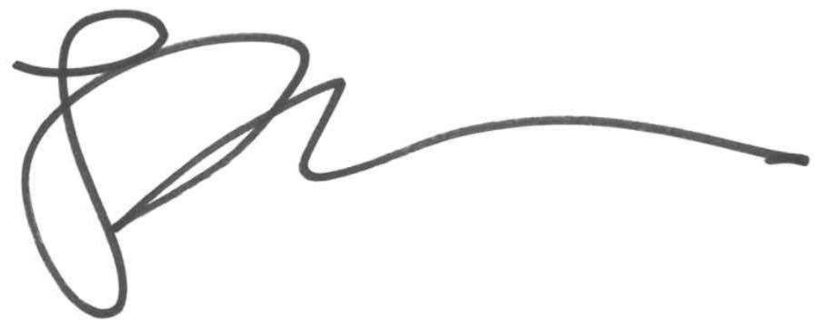

Jessie Lawrence, Director
City of Philadelphia, Department of Planning & Development
Division of Housing and Community Development

