NOTICE OF FINDING OF NO SIGNIFICANT IMPACT AND

NOTICE OF INTENT TO REQUEST RELEASE OF FUNDS

Date of Notice: April 9, 2026

City of Philadelphia
Division of Housing and Community Development
1234 Market Street, 17th Floor
Philadelphia, PA 19107
215-686-9760

These notices shall satisfy two separate but related procedural requirements for activities to be undertaken by the City of Philadelphia’s Division of Housing and Community Development (DHCD).

REQUEST FOR RELEASE OF FUNDS

On or about Apri 29, 2026, the City of Philadelphia will submit a request to the U.S. Department of Housing and Urban Development (HUD) for the release of Community Development Block Grant (CDBG) funds under Title I of the Housing and Community Development Act of 1974, as amended; and the City of Philadelphia will authorize the Philadelphia Housing Authority (PHA) to submit to HUD a request for release of funds under Section 9 funds under the United States Housing Act of 1937, as amended, to undertake the following project: New Africa Center.

Project Title: ER-25-024; New Africa Center

Purpose: The applicant requests funding to construct a 5-story building, with a cultural center on the ground floor, and 33 affordable units above. Two of the four lots are currently vacant, while the other two have 3-story mixed use attached buildings that are vacant and will be demolished

Location: 4237, 4239, 4241, 4243 Lancaster Avenue, Philadelphia, PA 19104

Estimated Cost: The total development cost is $10,643,383, including approximately CDBG: $500,000; the Project will receive an operating subsidy for 33 units in the Development from the Philadelphia Housing Authority (“PHA”). The Development will initially close as a Mixed Finance ACC transaction with 33 public housing units, which will convert to Project-Based Vouchers through a Faircloth to Rental Assistance Demonstration (Faircloth to RAD) transaction program.

FINDING OF NO SIGNIFICANT IMPACT

The City of Philadelphia has determined that the project will have no significant impact on the human environment. Therefore, an Environmental Impact Statement under the National Environmental Policy Act of 1969 (NEPA) is not required. Additional project information is contained in the Environmental Review Record (ERR). The ERR will be made available to the public for review either electronically or by U.S. mail. Please submit your request by U.S. mail to City of Philadelphia, City Planning Commission, 1515 Arch Street, 13th Floor, Philadelphia, PA 19102 or by email to planning@phila.gov. The legal notice can be accessed online at

the following website

www.phila.gov/dhcd/legal-notices

POSTING INFORMATION

This Notice will be posted at the Haverford Library Branch located at 5543 Haverford Avenue; Philadelphia, PA 19139; and this legal notice is also posted online at the following website:

www.phila.gov/dhcd/legal-notices

PUBLIC COMMENTS

Any individual, group, or agency may submit written comments on the ERR to DHCD. All comments received by April 28, 2026, will be considered by the DHCD prior to authorizing submission of a request for release of funds. Comments should specify which Notice they are addressing.

ENVIRONMENTAL CERTIFICATION

The City of Philadelphia certifies to HUD that Jessie Lawrence, in his capacity as Director of the Department of Planning and Development/Division of Housing and Community Development consents to accept the jurisdiction of the Federal Courts if an action is brought to enforce responsibilities in relation to the environmental review process and that these responsibilities have been satisfied. HUD’s approval of the certification satisfies its responsibilities under NEPA and related laws and authorities and allows the City of Philadelphia and the PHA to use Program funds.

OBJECTIONS TO RELEASE OF FUNDS

HUD will accept objections to its release of funds and the City’s certification for a period of 15 days following the anticipated submission date or its actual receipt of the request (whichever is later) only if they are on one of the following bases: (a) the certification was not executed by the Certifying Officer of the City (b) the City has omitted a step or failed to make a decision or finding required by HUD regulations at 24 CFR part 58; (c) the grant recipient or other participants in the development process have committed funds, incurred costs or undertaken activities not authorized by 24 CFR Part 58 before approval of a release of funds by HUD; or (d) another Federal agency acting pursuant to 40 CFR Part 1504 has submitted a written finding that the project is unsatisfactory from the standpoint of environmental quality.

Objections must be prepared and submitted in accordance with the required procedures (24 CFR Part 58) and shall be addressed to the Philadelphia Office of Community Planning and Development at CPDRROFPHI@hud.gov . Potential objectors should contact HUD to verify the actual last day of the objection period.
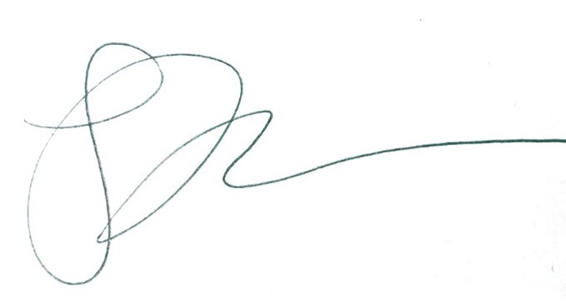

Jessie Lawrence, Director
Department of Planning & Development/Division of Housing & Community Development
City of Philadelphia

