BEFORE THE PHILADELPHIA WATER, SEWER, AND STORM WATER RATE BOARD

In the Matter of the Philadelphia Water Department’s Proposed Change in Water, Wastewater, and Stormwater Rates and Related Charges

Fiscal Years 2024 – 2025 Rates and Charges to Become Effective September 1, 2023

The enclosed correspondence represents additional facts and details that supplement the motion filed by this participant on 4/28/25 re the Hearing Officer’s allegation that my statements were “baseless claims”.

(1)  Hearing Officer, your statement relative to my "baseless claim" is wrong, without merit and contradicts the violation of my First Amendment Rights issued by WRB counsel in his May 2018 directive wherein he blocks my right "to petition the government for a redress of grievances."

“…. *The City’s correspondence with you is over, as are any and all City investigations at your behest….”*

(2) Additionally, if I had not been continually interrupted and eventually blocked from readmittance to the ZOOM conference, I would in fact provide additional details that are relevant and  impact on the setting of water and sewer rates.  The evidence and public record in city files indicate that WRB Counsel, Daniel Cantu Hertzler, as supervisor in the Solicitor's Regulatory Unit, was directly responsible for approving a discount of 55% on a PWD HELP loan for a consumer in 2010 between the consumer, PWD and the City of Philadelphia.  Since there is evidence of such financial discount without any details, evidence, etc. to support such an expenditure of PWD revenue, the request for PWD HELP loan records would be of value to ensure when and how often such a discount was provided to other PWD consumers and hopefully with the reasons uncovered for such loss of revenue.

(3) Also, as supervisor of the Solicitor's unit that provided legal counsel to the Tax Review Board as well as counsel for the personnel in the Office of Administrative Review that conducted hearings where PWD consumers appealed expenses related to PWD operations and services, over a period of many years, Daniel Cantu Hertzler failed to inform many, many petitioners of Article 15, TRB regulations that they had the possibility of accessing a second appeal with the Tax Review Board after their first appeal was denied.  The real impact of such failure and incompetence in this process affected a certain percentage of TRB petitioners who possibly could have been successful in their second appeal and chose not to access the expensive, lengthy and difficult appeal to the Court of Common Pleas after their first denial (and kept in the dark re their second appeal).

So, yes, Hearing Officer, these are relevant issues, genuine concerns, fact-based and evidence-supported which reflect on (Item 1) the integrity of the Integrity Award winner of the City of Philadelphia by violating a citizen's First Amendment Rights, (Item 2) financial professionalism given the discounted and questionable PWD HELP loan he directly approved and (Item 3) the competence of a senior deputy city solicitor charged with ensuring that petitioners to the TRB, who are advised via the city website that legal representation is unnecessary in TRB proceedings, are properly and fully informed of all of the elements and options of the TRB proceedings.

Absent a response to the facts and evidence presented in this message to the charge of "baseless claim" by the WRB in a timely manner, I will pursue the review and investigation of such professional conduct and decision-making via whatever professional and public sources available to this Philadelphia citizen and PWD consumer.

Finally, the following message was sent to the Chairman, Water Rate Board concerning the exchange between this participant and the Hearing Officer on 4/23/25:

skiadvocat@aol.com

From:skiadvocat@aol.com

To:Sonny Popowsky,MICHAEL SKIENDZIELEWSKI

Mon, Apr 28 at 11:49 AM

Mr. Popowsky

Is the ZOOM meeting transcript as well as the video from 4/23 included in the public record and posted on the WRB website?

If I am interested in filing a motion regarding the professionalism of the Hearing Officer during my presentation on 4/23 WITHIN the WRB hearing process, who would I address it to and where would I file it?

Have you read and/or listened to the exchange between the Hearing Officer and this WRB participant?

Michael Skiendzielewski

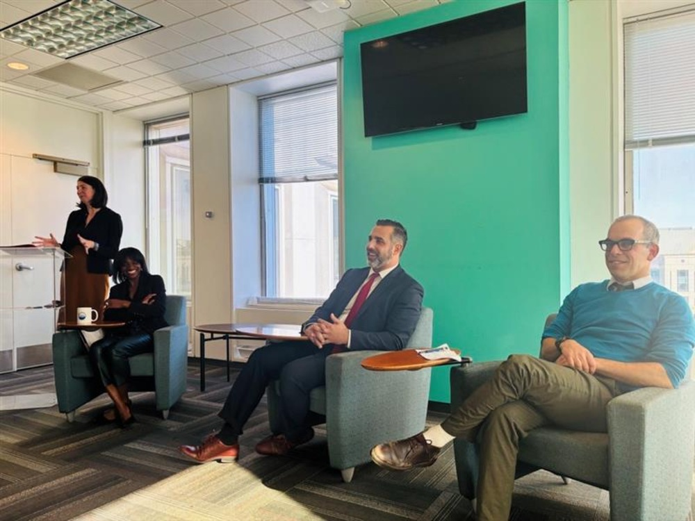Figure 1: INTEGRITY WEEK - CITY OF PHILADELPHIA – 2024

Chief Integrity Officer, Deputy Chief Integrity Officer, Inspector General, City of Philadelphia, Chair of Compliance, Office of the City Solicitor, City of Philadelphia

“A Focus on Ethical Governance and Transparency”

City Integrity Professionals, at their Integrity Week soiree, appear to be relaxed and carefree, regardless of the facts, evidence, unprofessional and unethical conduct of senior city officials that has been sent to them over and over again.

"Integrity is the foundation of trust and transparency—trust in our government, processes, and each other. Integrity Week reminded us that pursuing an ethical government is an ongoing journey,"

Proofreading needs some improvement….title should read “Integrity Weak”