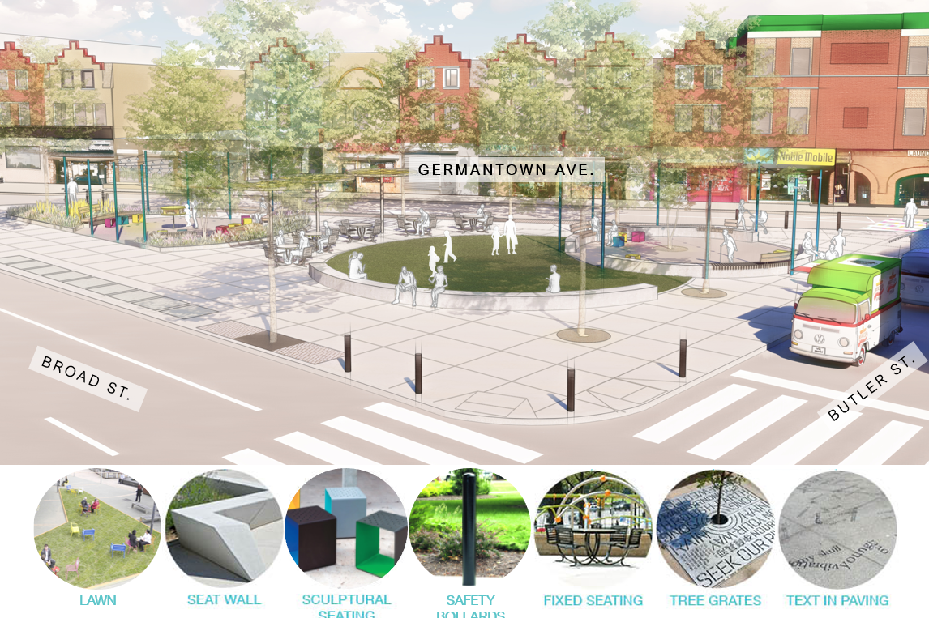
Image 1:
Graphic illustration of the draft design for the triangle at Broad Street, Butler Street, and Germantown Avenue. This view is looking southwest from the corner of Broad and Butler Streets. There are overlapping circles that define the space. Raised semi-curved planter beds are toward the southern end of the triangle. The planter beds have plants and flowers in them. Overlapping with the northwest part of the lawn is a large, paved circle with a very short, wide wall around the edge that can be used as seating, called a seat wall. Several platforms, some with backs, are embedded in the top of the seat wall, forming benches along the seat wall. There are several poles around the outside of the seat wall with string lights hanging from the tops. The string lights cross over the paved circle. Inside the paved circle are colorful cube-shaped seats that are open in the front and back. There is also a tree planted inside the paved circle. Just south of the lawn are colorful round metal canopies to provide shade, called shade structures, with tables and chairs underneath them. The tables and chairs are fixed to the ground. The tables are round, and the seats have backs. Trees line the sidewalks around the triangle, with decorative metal grates in the sidewalk around the base of their trunks. These grates and/or some of the paving or seat walls in the space could be engraved with text and quotes. There are black, thick metal poles about 3 feet high, called bollards, around the edge of the sidewalk near where it meets the street. These are to protect cars from accidentally going into the space.

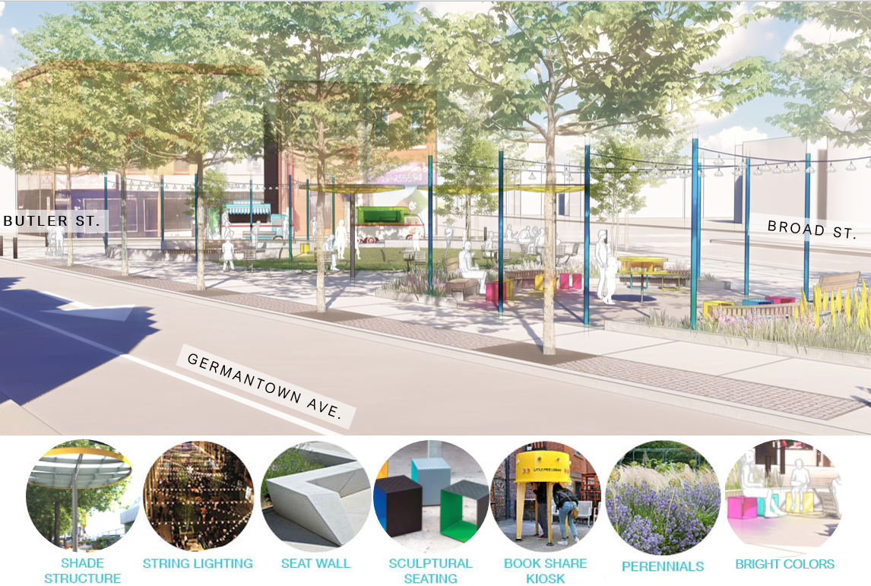
Graphic illustration of the draft design for the triangle at Broad Street, Butler Street, and Germantown Avenue. This view is looking northeast from Germantown Avenue, near the intersection with Broad. Raised semi-curved planter beds are toward the southern end of the triangle. The planter beds have plants and flowers in them. The planter beds curve around part of a smaller paved circle. The edges of the planter beds around the circle are a very short, wide wall that can be used as seating, called a seat wall. In the middle of the paved circle is a book share kiosk. Several platforms, some with backs, are embedded in the top of the seat wall, forming benches along the seat wall. There are several poles in the planters, outside of the seat wall with string lights hanging from the tops. The string lights cross over the paved circle. Inside the paved circle are colorful cube-shaped seats that are open in the front and back. Just north of the paved circle and planters are colorful round metal canopies to provide shade, called shade structures, with tables and chairs underneath them. The tables and chairs are fixed to the ground. The tables are round, and the seats have backs. Trees line the sidewalks around the triangle, with decorative metal grates in the sidewalk around the base of their trunks. These grates and/or some of the paving or seat walls in the space could be engraved with text and quotes. There are black, thick metal poles about 3 feet high, called bollards, around the edge of the sidewalk near where it meets the street. These are to protect cars from accidentally going into the space.
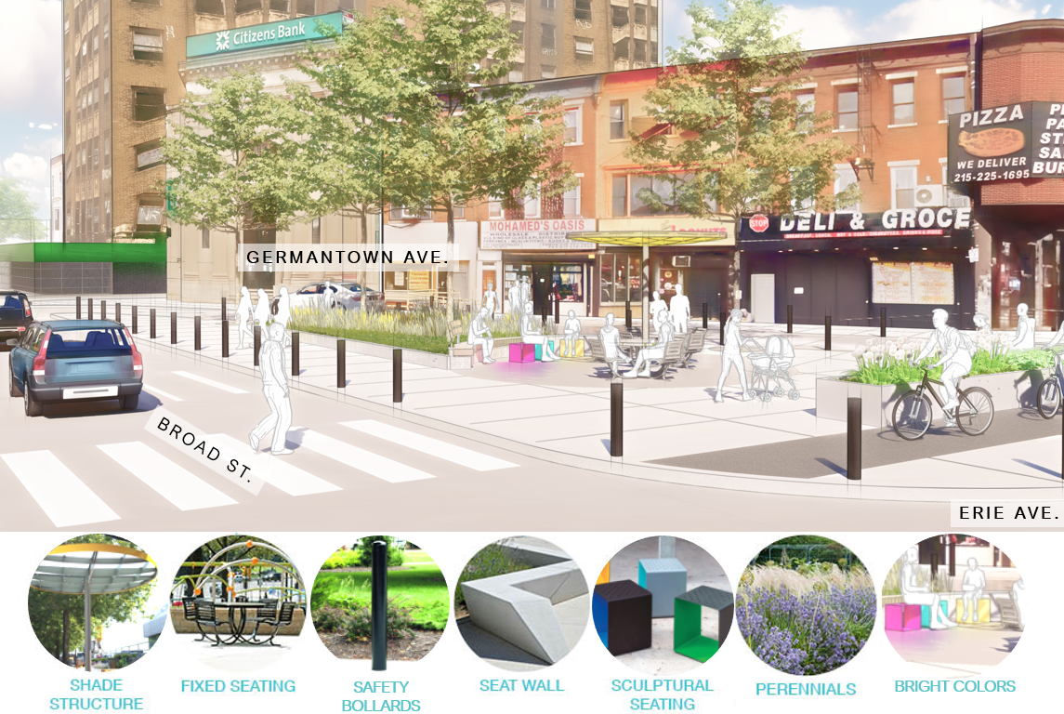
Graphic illustration of the draft design for the triangle at Broad Street, Erie Avenue, and Germantown Avenue. This view is looking northeast from the intersection of Broad Street and Erie Avenue. The Erie Avenue bicycle lane is raised above the street and runs along the southern edge of the triangle. The bicycle lane is separated from the rest of the triangle by a raised planter bed. Another raised planter bed is in the middle of the triangle. The planter beds have plants and flowers in them. The planter bed in the middle curves around part of a smaller paved circle. The curved edge of that planter bed around the circle is a very short, wide wall that can be used as seating, called a seat wall. A few platforms, some with backs, are embedded in the top of the seat wall, forming benches along the seat wall. Inside the paved circle are colorful cube-shaped seats that are open in the front and back. Also inside the paved circle is a colorful round metal shade canopy, called a shade structure, with tables and chairs underneath them. The tables and chairs are fixed to the ground. The tables are round, and the seats have backs. Trees line the sidewalk along Germantown Avenue, with decorative metal grates in the sidewalk around the base of their trunks. These grates and/or some of the paving or seat walls in the space could be engraved with text and quotes. There are black, thick metal poles about 3 feet high, called bollards, around the edge of the sidewalk near where it meets the street. These are to protect cars from accidentally going into the space

