INSTRUCTIONS
This Checklist is an implementation tool of the Philadelphia Complete Streets Handbook (the “Handbook”) and enables City engineers and planners to review projects for their compliance with the Handbook’s policies. The handbook provides design guidance and does not supersede or replace language, standards or policies established in the City Code, City Plan, or Manual on Uniform Traffic Control Devices (MUTCD).
The Philadelphia City Planning Commission receives this Checklist as a function of its Civic Design Review (CDR) process. This checklist is used to document how project applicants considered and accommodated the needs of all users of city streets and sidewalks during the planning and/or design of projects affecting public rights-of-way. Departmental reviewers will use this checklist to confirm that submitted designs incorporate complete streets considerations (see §11-901 of The Philadelphia Code). Applicants for projects that require Civic Design Review shall complete this checklist and attach it to plans submitted to the Philadelphia City Planning Commission for review, along with an electronic version.
The Handbook and the checklist can be accessed at http://www.phila.gov/CityPlanning/projectreviews/Pages/CivicDesignReview.aspx
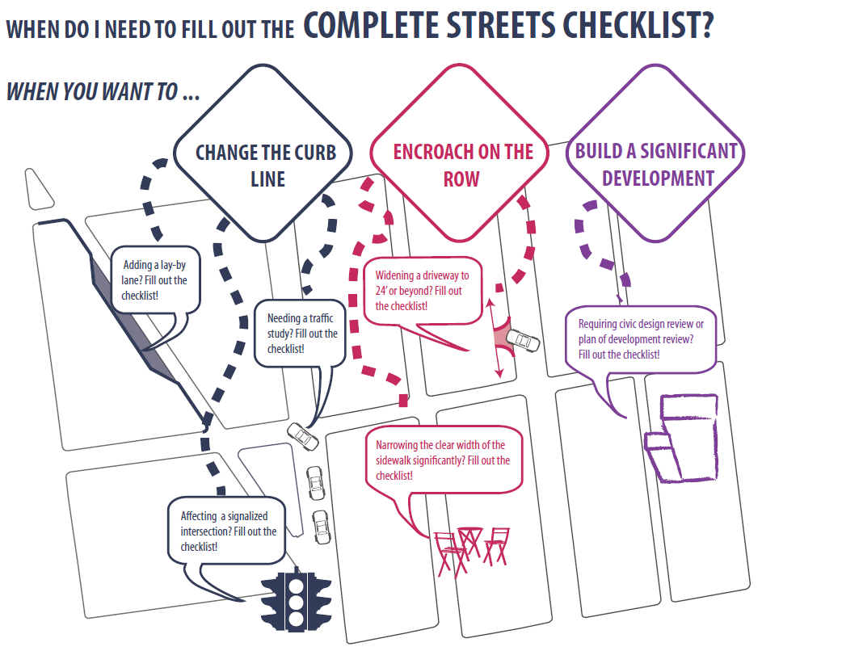

PRELIMINARY PCPC REVIEW AND COMMENT: | DATE
FINAL STREETS DEPT REVIEW AND COMMENT: | DATE

INSTRUCTIONS (continued)
APPLICANTS SHOULD MAKE SURE TO COMPLY WITH THE FOLLOWING REQUIREMENTS:
- This checklist is designed to be filled out electronically in Microsoft Word format. Please submit the Word version of the checklist. Text fields will expand automatically as you type.
- All plans submitted for review must clearly dimension the widths of the Furnishing, Walking, and Building Zones (as defined in Section 1 of the Handbook). “High Priority” Complete Streets treatments (identified in Table 1 and subsequent sections of the Handbook) should be identified and dimensioned on plans.
- All plans submitted for review must clearly identify and site all street furniture, including but not limited to bus shelters, street signs and hydrants.
- Any project that calls for the development and installation of medians, bio-swales and other such features in the right-of-way may require a maintenance agreement with the Streets Department.
- ADA curb-ramp designs must be submitted to Streets Department for review
- Any project that significantly changes the curb line may require a City Plan Action. The City Plan Action Application is available at http://www.philadelphiastreets.com/survey-and-design-bureau/city-plans-unit . An application to the Streets Department for a City Plan Action is required when a project plan proposes the:
  - Placing of a new street;
  - Removal of an existing street;
  - Changes to roadway grades, curb lines, or widths; or
  - Placing or striking a city utility right-of-way.
Complete Streets Review Submission Requirement*:
- EXISTING CONDITIONS SITE PLAN, should be at an identified standard engineering scale
  - FULLY DIMENSIONED
  - CURB CUTS/DRIVEWAYS/LAYBY LANES
  - TREE PITS/LANDSCAPING
  - BICYCLE RACKS/STATIONS/STORAGE AREAS
  - TRANSIT SHELTERS/STAIRWAYS
- PROPOSED CONDITIONS SITE PLAN, should be at an identified standard engineering scale
  - FULLY DIMENSIONED, INCLUDING DELINEATION OF WALKING, FURNISHING, AND BUILDING ZONES AND PINCH POINTS
  - PROPOSED CURB CUTS/DRIVEWAYS/LAYBY LANES
  - PROPOSED TREE PITS/LANDSCAPING
  - BICYCLE RACKS/STATIONS/STORAGE AREAS
  - TRANSIT SHELTERS/STAIRWAYS

*APPLICANTS PLEASE NOTE: ONLY FULL-SIZE, READABLE SITE PLANS WILL BE ACCEPTED. ADDITIONAL PLANS MAY BE REQUIRED AND WILL BE REQUESTED IF NECESSARY

GENERAL PROJECT INFORMATION
- PROJECT NAME | - DATE
- APPLICANT NAME  - APPLICANT CONTACT INFORMATION | - PROJECT AREA: list precise street limits and scope
- OWNER NAME

- OWNER CONTACT INFORMATION

- ENGINEER / ARCHITECT NAME

- ENGINEER / ARCHITECT CONTACT INFORMATION

- STREETS: List the streets associated with the project. Complete Streets Types can be found at www.phila.gov/map under the “Complete Street Types” field. Complete Streets Types are also identified in Section 3 of the Handbook.
Also available here: http://metadata.phila.gov/#home/datasetdetails/5543867320583086178c4f34/
STREET | FROM | TO | COMPLETE STREET TYPE
- Does the Existing Conditions site survey clearly identify the following existing conditions with dimensions?
- Parking and loading regulations in curb lanes adjacent to the site | YES NO
- Street Furniture such as bus shelters, honor boxes, etc. | YES NO N/A
- Street Direction | YES NO
- Curb Cuts | YES NO N/A
- Utilities, including tree grates, vault covers, manholes, junction boxes, signs, lights, poles, etc. | YES NO N/A
- Building Extensions into the sidewalk, such as stairs and stoops | YES NO N/A

APPLICANT: General Project Information
Additional Explanation / Comments:

DEPARTMENTAL REVIEW: General Project Information

PEDESTRIAN COMPONENT (Handbook Section 4.3)
- SIDEWALK: list Sidewalk widths for each street frontage. Required Sidewalk widths are listed in Section 4.3 of the Handbook.
STREET FRONTAGE | TYPICAL SIDEWALK WIDTH  (BUILDING LINE TO CURB)  Required / Existing / Proposed | CITY PLAN SIDEWALK WIDTH  Existing / Proposed
 | / / | /
 | / / | /
 | / / | /
 | / / | /
- WALKING ZONE: list Walking Zone widths for each street frontage. The Walking Zone is defined in Section 4.3 of the Handbook, including required widths.
STREET FRONTAGE | WALKING ZONE  Required / Existing / Proposed
 | / /
 | / /
 | / /
 | / /
- VEHICULAR INTRUSIONS: list Vehicular Intrusions into the sidewalk. Examples include but are not limited to; driveways, lay-by lanes, etc. Driveways and lay-by lanes are addressed in sections 4.8.1 and 4.6.3, respectively, of the Handbook.
EXISTING VEHICULAR INTRUSIONS
INTRUSION TYPE | INTRUSION WIDTH | PLACEMENT
PROPOSED VEHICULAR INTRUSIONS
INTRUSION TYPE | INTRUSION WIDTH | PLACEMENT

PEDESTRIAN COMPONENT (continued)
 |  | DEPARTMENTAL APPROVAL
- When considering the overall design, does it create or enhance a pedestrian environment that provides safe and comfortable access for all pedestrians at all times of the day? | YES NO | YES NO

APPLICANT: Pedestrian Component
Additional Explanation / Comments:

DEPARTMENTAL REVIEW: Pedestrian Component
Reviewer Comments:

BUILDING & FURNISHING COMPONENT (Handbook Section 4.4)
- BUILDING ZONE: list the MAXIMUM, existing and proposed Building Zone width on each street frontage. The Building Zone is defined as the area of the sidewalk immediately adjacent to the building face, wall, or fence marking the property line, or a lawn in lower density residential neighborhoods. The Building Zone is further defined in section 4.4.1 of the Handbook.
STREET FRONTAGE | MAXIMUM BUILDING ZONE WIDTH  Existing / Proposed
 | /
 | /
 | /
 | /
- FURNISHING ZONE: list the MINIMUM, recommended, existing, and proposed Furnishing Zone widths on each street frontage. The Furnishing Zone is further defined in section 4.4.2 of the Handbook.
STREET FRONTAGE | MINIMUM FURNISHING ZONE WIDTH  Recommended / Existing / Proposed
 | / /
 | / /
 | / /
 | / /

- Identify proposed “high priority” building and furnishing zone design treatments that are incorporated into the design plan, where width permits (see Handbook Table 1). Are the following treatments identified and dimensioned on the plan? |  | DEPARTMENTAL APPROVAL
- Bicycle Parking | YES NO N/A | YES NO
- Lighting | YES NO N/A | YES NO
- Benches | YES NO N/A | YES NO
- Street Trees | YES NO N/A | YES NO
- Street Furniture | YES NO N/A | YES NO
- Does the design avoid tripping hazards? | YES NO N/A | YES NO
- Does the design avoid pinch points? Pinch points are locations where the Walking Zone width is less than the required width identified in item 13, or requires an exception | YES NO N/A | YES NO

BUILDING & FURNISHING COMPONENT (continued)
- Do street trees and/or plants comply with street installation requirements (see sections 4.4.7 & 4.4.8) | YES NO N/A | YES NO
- Does the design maintain adequate visibility for all roadway users at intersections? | YES NO N/A | YES NO

APPLICANT: Building & Furnishing Component
Additional Explanation / Comments:

DEPARTMENTAL REVIEW: Building & Furnishing Component
Reviewer Comments:

BICYCLE COMPONENT (Handbook Section 4.5)
- List elements of the project that incorporate recommendations of the Pedestrian and Bicycle Plan, located online at http://phila2035.org/wp-content/uploads/2012/06/bikePedfinal2.pdf

- List the existing and proposed number of bicycle parking spaces, on- and off-street. Bicycle parking requirements are provided in The Philadelphia Code, Section 14-804.
BUILDING / ADDRESS | REQUIRED SPACES | ON-STREET  Existing / Proposed | ON SIDEWALK  Existing / Proposed | OFF-STREET  Existing / Proposed
 |  | / | / | /
 |  | / | / | /
 |  | / | / | /
 |  | / | / | /

- Identify proposed “high priority” bicycle design treatments (see Handbook Table 1) that are incorporated into the design plan, where width permits. Are the following “High Priority” elements identified and dimensioned on the plan? |  | DEPARTMENTAL APPROVAL
- Conventional Bike Lane | YES NO N/A | YES NO
- Buffered Bike Lane | YES NO N/A | YES NO
- Bicycle-Friendly Street  - Indego Bicycle Share Station | YES NO N/A  YES NO N/A | YES NO  YES NO
- Does the design provide bicycle connections to local bicycle, trail, and transit networks? | YES NO N/A | YES NO
- Does the design provide convenient bicycle connections to residences, work places, and other destinations? | YES NO N/A | YES NO

APPLICANT: Bicycle Component
Additional Explanation / Comments:

DEPARTMENTAL REVIEW: Bicycle Component
Reviewer Comments:

CURBSIDE MANAGEMENT COMPONENT (Handbook Section 4.6)
 |  | DEPARTMENTAL APPROVAL
- Does the design limit conflict among transportation modes along the curb? | YES NO | YES NO
- Does the design connect transit stops to the surrounding pedestrian network and destinations? | YES NO N/A | YES NO
- Does the design provide a buffer between the roadway and pedestrian traffic? | YES NO N/A | YES NO
- How does the proposed plan affect the accessibility, visibility, connectivity, and/or attractiveness of public transit? |  | YES NO

APPLICANT: Curbside Management Component
Additional Explanation / Comments:

DEPARTMENTAL REVIEW: Curbside Management Component
Reviewer Comments:

VEHICLE / CARTWAY COMPONENT (Handbook Section 4.7)
- If lane changes are proposed, , identify existing and proposed lane widths and the design speed for each street frontage;
STREET | FROM | TO | LANE WIDTHS  Existing / Proposed | DESIGN SPEED
 |  |  | /
 |  |  | /
 |  |  | /
 |  |  | /

 |  | DEPARTMENTAL APPROVAL
- What is the maximum AASHTO design vehicle being accommodated by the design? |  | YES NO
- Will the project affect a historically certified street? An inventory of historic streets⁽¹⁾ is maintained by the Philadelphia Historical Commission. | YES NO | YES NO
- Will the public right-of-way be used for loading and unloading activities? | YES NO | YES NO
- Does the design maintain emergency vehicle access? | YES NO | YES NO
- Where new streets are being developed, does the design connect and extend the street grid? | YES NO N/A | YES NO
- Does the design support multiple alternative routes to and from destinations as well as within the site? | YES NO N/A | YES NO
- Overall, does the design balance vehicle mobility with the mobility and access of all other roadway users? | YES NO | YES NO

APPLICANT: Vehicle / Cartway Component
Additional Explanation / Comments:

DEPARTMENTAL REVIEW: Vehicle / Cartway Component
Reviewer Comments:

- http://www.philadelphiastreets.com/images/uploads/documents/Historical_Street_Paving.pdf

URBAN DESIGN COMPONENT (Handbook Section 4.8)
 |  | DEPARTMENTAL APPROVAL
- Does the design incorporate windows, storefronts, and other active uses facing the street? | YES NO N/A | YES NO
- Does the design provide driveway access that safely manages pedestrian / bicycle conflicts with vehicles (see Section 4.8.1)? | YES NO N/A | YES NO
- Does the design provide direct, safe, and accessible connections between transit stops/stations and building access points and destinations within the site? | YES NO N/A | YES NO

APPLICANT: Urban Design Component
Additional Explanation / Comments:

DEPARTMENTAL REVIEW: Urban Design Component
Reviewer Comments:

INTERSECTIONS & CROSSINGS COMPONENT (Handbook Section 4.9)
- If signal cycle changes are proposed, please identify Existing and Proposed Signal Cycle lengths; if not, go to question No. 48.
SIGNAL LOCATION | EXISTING  CYCLE LENGTH | PROPOSED  CYCLE LENGTH

 |  | DEPARTMENTAL APPROVAL
- Does the design minimize the signal cycle length to reduce pedestrian wait time? | YES NO N/A | YES NO
- Does the design provide adequate clearance time for pedestrians to cross streets? | YES NO N/A | YES NO
- Does the design minimize pedestrian crossing distances by narrowing streets or travel lanes, extending curbs, reducing curb radii, or using medians or refuge islands to break up long crossings?  If yes, City Plan Action may be required. | YES NO N/A | YES NO
- Identify “High Priority” intersection and crossing design treatments (see Handbook Table 1) that will be incorporated into the design, where width permits. Are the following “High Priority” design treatments identified and dimensioned on the plan? |  | YES NO
- Marked Crosswalks | YES NO N/A | YES NO
- Pedestrian Refuge Islands | YES NO N/A | YES NO
- Signal Timing and Operation | YES NO N/A | YES NO
- Bike Boxes | YES NO N/A | YES NO
- Does the design reduce vehicle speeds and increase visibility for all modes at intersections? | YES NO N/A | YES NO
- Overall, do intersection designs limit conflicts between all modes and promote pedestrian and bicycle safety? | YES NO N/A | YES NO

APPLICANT: Intersections & Crossings Component
Additional Explanation / Comments:

DEPARTMENTAL REVIEW: Intersections & Crossings Component
Reviewer Comments:

ADDITIONAL COMMENTS

APPLICANT
Additional Explanation / Comments:

DEPARTMENTAL REVIEW
Additional Reviewer Comments:

